Practical 8: Binary Tree Traversals and Binary Search Tree Insertion
Practical Aim To implement binary tree traversals and binary search tree insertion, and develop the ability to reason about how the order of visiting nodes changes the information retrieved from a tree.
Problem 1: A company stores its organizational hierarchy as a tree — the CEO at the top, managers below, and employees at the leaves. Different departments need the hierarchy printed in different orders: HR wants each manager printed between their left and right sub-teams, the archive department wants each manager printed before their sub-teams, the payroll department wants each manager printed after all their sub-teams are listed, and the floor manager wants everyone printed level by level from top to bottom. Given a binary tree representing the hierarchy, implement all four printing orders and display the result of each. Describe how your solution for level-by-level printing differs from the other three. What additional structure did you need to use, and why does the same recursive approach that works for the other three not directly apply here?
CODE:
#include <iostream>
#include <queue>
using namespace std;
struct Node {
int data;
Node* left;
Node* right;
};
Node* createNode(int value) {
Node* newNode = new Node;
newNode->data = value;
newNode->left = NULL;
newNode->right = NULL;
return newNode;
}
void inorder(Node* root) {
if (root == NULL)
return;
inorder(root->left);
cout << root->data << " ";
inorder(root->right);
}
void preorder(Node* root) {
if (root == NULL)
return;
cout << root->data << " ";
preorder(root->left);
preorder(root->right);
}
void postorder(Node* root) {
if (root == NULL)
return;
postorder(root->left);
postorder(root->right);
cout << root->data << " ";
}
void levelOrder(Node* root) {
if (root == NULL)
return;
queue<Node*> q;
q.push(root);
while (!q.empty()) {
Node* current = q.front();
q.pop();
cout << current->data << " ";
if (current->left != NULL)
q.push(current->left);
if (current->right != NULL)
q.push(current->right);
}
}
int main() {
Node* root = NULL;
int n, value;
cout << "Enter number of nodes: ";
cin >> n;
if (n <= 0) {
cout << "Tree is empty.";
return 0;
}
cout << "Enter root value: ";
cin >> value;
root = createNode(value);
queue<Node*> q;
q.push(root);
for (int i = 1; i < n; i++) {
Node* current = q.front();
q.pop();
cout << "Enter left child of " << current->data
<< " (enter -1 if none): ";
cin >> value;
if (value != -1) {
current->left = createNode(value);
q.push(current->left);
}
if (i < n) {
cout << "Enter right child of " << current->data
<< " (enter -1 if none): ";
cin >> value;
if (value != -1) {
current->right = createNode(value);
q.push(current->right);
}
}
}
cout << "\nInorder: ";
inorder(root);
cout << "\nPreorder: ";
preorder(root);
cout << "\nPostorder: ";
postorder(root);
cout << "\nLevel order: ";
levelOrder(root);
return 0;
}
OUTPUT:
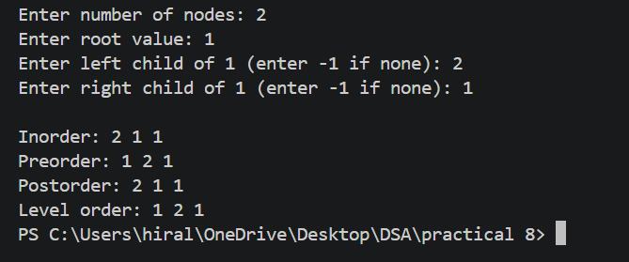
Problem 2: A school library uses a system where every book is assigned a unique code when it arrives. Books are organized so that at any shelf position, all books to the left have smaller codes and all books to the right have larger codes. This arrangement lets staff find any book quickly by always knowing which direction to look. Given a sequence of book codes arriving one by one, insert each into the correct position and print the inorder sequence after all insertions are complete. Describe how your solution decides where to place each new book code. What property of the final inorder sequence tells you whether all insertions were performed correctly?
CODE:
#include <iostream>
using namespace std;
struct Node {
int data;
Node* left;
Node* right;
};
Node* createNode(int value) {
Node* newNode = new Node;
newNode->data = value;
newNode->left = NULL;
newNode->right = NULL;
return newNode;
}
Node* insert(Node* root, int value) {
if (root == NULL)
return createNode(value);
if (value < root->data)
root->left = insert(root->left, value);
else if (value > root->data)
root->right = insert(root->right, value);
return root;
}
void inorder(Node* root) {
if (root == NULL)
return;

inorder(root->left);
cout << root->data << " ";
inorder(root->right);
}
int main() {
Node* root = NULL;
int n, value;
cout << "Enter number of book codes: ";
cin >> n;
if (n <= 0) {
cout << "No book codes entered.";
return 0;
}
for (int i = 0; i < n; i++) {
cout << "Enter book code: ";
cin >> value;
root = insert(root, value);
}
cout << "\nBook codes in ascending order: ";
inorder(root);
return 0;
}
OUTPUT:
